Solution Assessment Report



Final Report

Prepared for

Update [Customer Name] in doc properties

13-Jun-15

Version 1.0 Final

Prepared by

[Author Position]

[Author Email]

Contributors

**[Contributors]**

Revision and Signoff Sheet

Change Record

|  |  |  |  |
| --- | --- | --- | --- |
| Date | Author | Version | Change Reference |
|  |  |  |  |
|  |  |  |  |
|  |  |  |  |

Reviewers

|  |  |  |  |
| --- | --- | --- | --- |
| Name | Version Approved | Position | Date |
|  |  |  |  |
|  |  |  |  |
|  |  |  |  |

Table of Contents

1 Executive Summary 6

2 Vision for SharePoint 7

2.1 Cloud ready 7

2.2 Agility for business 7

2.3 Cost efficiency 8

2.4 Customize for business value 8

3 High Level roadmap 9

4 Current environment and challenges 9

5 Future recommended architecture 9

6 SharePoint Assessment report 10

6.1 FTC solutions analyzed 10

6.2 Provisioning 10

6.2.1 Customer requirements 10

6.2.2 Considerations and workarounds 10

6.3 Branding 11

6.3.1 Customer requirements 11

6.3.2 Considerations and workarounds 11

6.4 UX Components 11

6.4.1 Customer requirements 11

6.4.2 Considerations and workarounds 11

6.5 Search 11

6.5.1 Customer requirements 11

6.5.2 Considerations and workarounds 12

6.6 Composite and Business apps 12

6.6.1 Customer requirements 12

6.6.2 Considerations and workarounds 12

6.7 Profile enrichment 12

6.7.1 Customer requirements 12

6.7.2 Considerations and workarounds 12

6.8 Web Content Management 13

6.8.1 Customer requirements 13

6.8.2 Considerations and workarounds 13

6.9 Enterprise Content Management 13

6.9.1 Customer requirements 13

6.9.2 Considerations and workarounds 13

6.10 Other 13

6.10.1 Customer requirements 13

6.10.2 Considerations and workarounds 14

1. Executive Summary

Update below text to match your customer needs

We approached the Contoso Solution Assessment from multiple angles. The primary purpose of the assessment was to analyze how the future Office 365 Single Tenant environment complies with the current business and technical requirements. As part of the assessment, Contoso clarified its SharePoint vision and we recorded it as a guidance for the roadmap planning.

Contoso SharePoint Vision statements guiding the future planning and model for SharePoint usage.

* *Cloud ready*
  + Processes, customizations and models created for Contoso have to be cloud ready. This means that the customizations should work in both public and in private cloud.
* *Agility for business*
  + Platform needs to be agile enough to be able to cater to the needs and requirements of the business. This means that, for instance, releasing new independent Internet facing sites should happen in matter of days, not in weeks or months.
* *Cost efficiency*
  + Configure before customizing. Minimize maintenance and operational costs by reducing unnecessary complexity.
* *Customize for business value*
  + Create clear business cases for each customization to ensure that the value is worthy of the investment (ROI). Analyze the short and long-term impact.

In order to support the transformation from full trust code to the app model, we will discuss four supporting work streams in detail.

* Modern responsive apps
* App Developer guidance
* Environments and ALM
* Provider hosted app hosting

1. Vision for SharePoint

Update below text to match your customer needs

The following picture defines the high-level principles of the Contoso SharePoint Vision. These principles drive the transformation from full trust code solutions to the app model.

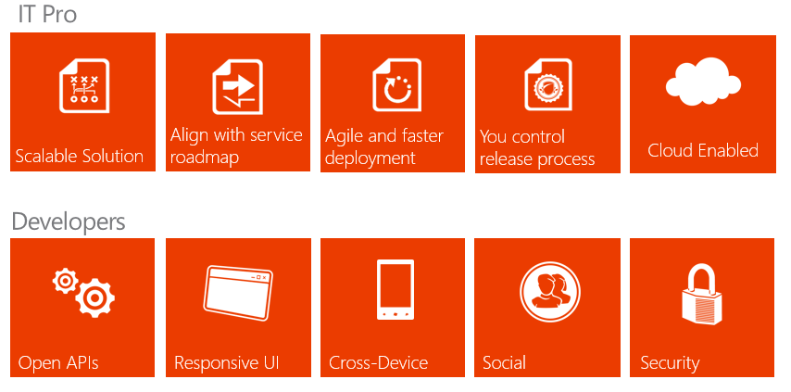

* 1. Cloud ready

Contoso should design all solutions and functionalities so that they work in both the private and public clouds. This provides flexibility with the hosting platform and deployments are not bound to a single platform in the future.

Customizations developed for Contoso platform should be in line with the SharePoint product roadmap to ensure agility for the deployments. By using the app model as the customization pattern, we can apply changes to sites without the constant need of IT personnel to perform detailed testing.

* 1. Agility for business

App model will result in faster deployments. All projects should aim to minimize complexity, concentrate on the primary objectives, and then offer the actual business functionality in the simplest possible way.

App model supports deployments of new sites and elements to site collections without any downtime. This model reduces the service and maintenance windows.

* 1. Cost efficiency

Minimize the unnecessary complexity involved with customizations if they do not provide direct business value. Use out of box features as far as possible.

Each required function should be evaluated against the value gained and the cost associated with the development and maintenance phase.

Minimize on-premises investments in SharePoint and gradually eliminate the need for the on-premises deployments in favor of cloud options.

* 1. Customize for business value

Each customization and project should have a clear business case (ROI) taking into account short and long-term costs associated with development, training and maintenance.

Out-of-the-box functionalities should always hold priority and customization should only occur if out of the box functionalities or apps from public market place cannot provide similar functionality.

Use the app model whenever possible to minimize operational impact of the customizations and to provide flexibility with the hosting options.

1. High Level roadmap

Provide a rough timeline of events

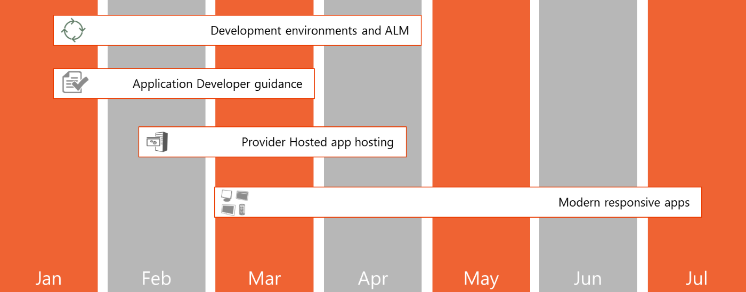

1. Current environment and challenges

Highlight the challenges with maintaining an on – premise environment. Also include the challenges been identified during Kick off sessions

1. Future recommended architecture

Recommend the App model that provides features without having to take actual ownership of the environment

1. SharePoint Assessment report

Write a short introduction that explains how this chapter is structured and why we have done this exercise.

* 1. FTC solutions analyzed

Describe which FTC solutions were in scope and the ones you have analyzed in detail. Also, describe how you performed the analysis and refer to the generated SPCAF (SharePoint Code Analysis Framework) reports.

Note that in the next chapters you will need to discuss the customer requirements and the equivalent FTC analysis grouped per scenario. If a particular scenario does not apply to the customer then just remove that chapter.

* 1. Provisioning
     1. Customer requirements

Describe the requirements the customer has listed for provisioning.

* + 1. Considerations and workarounds

Describe the potential issues you have detected while analyzing the FTC code. It is important that both the Microsoft Partner and the customer have a good understanding of these. If possible, list potential workarounds for these issues: changing the requirements could sometimes be a solution or there could be a technical workaround. When there’s NO solution found then clearly mark this as a “FTC to App blocker” which would require further follow-up.

* 1. Branding
     1. Customer requirements

Describe the requirements the customer has listed for branding.

* + 1. Considerations and workarounds

Describe the potential issues you have detected while analyzing the FTC code. It is important that both the Microsoft Partner and the customer have a good understanding of these. If possible, list potential workarounds for these issues: changing the requirements could sometimes be a solution or there could be a technical workaround. When there’s NO solution found then clearly mark this as a “FTC to App blocker” which would require further follow-up.

* 1. UX Components
     1. Customer requirements

Describe the requirements the customer has listed for UX components.

* + 1. Considerations and workarounds

Describe the potential issues you have detected while analyzing the FTC code. It is important that both the Microsoft Partner and the customer have a good understanding of these. If possible, list potential workarounds for these issues: changing the requirements could sometimes be a solution or there could be a technical workaround. When there’s NO solution found then clearly mark this as a “FTC to App blocker” which would require further follow-up.

* 1. Search
     1. Customer requirements

Describe the requirements the customer has listed for search.

* + 1. Considerations and workarounds

Describe the potential issues you have detected while analyzing the FTC code. It is important that both the Microsoft as the customer do have a good view on these. If possible, list potential workarounds for these issues: sometimes slightly changing the requirements can be a solution or there can be a technical workaround. When there’s NO solution found then clearly mark this as a FTC to App blocker as this will require further follow-up.

* 1. Composite and Business apps
     1. Customer requirements

Describe the requirements the customer has listed for composite and business apps.

* + 1. Considerations and workarounds

Describe the potential issues you have detected while analyzing the FTC code. It is important that both the Microsoft Partner and the customer have a good understanding of these. If possible, list potential workarounds for these issues: changing the requirements could sometimes be a solution or there could be a technical workaround. When there’s NO solution found then clearly mark this as a “FTC to App blocker” which would require further follow-up.

* 1. Profile enrichment
     1. Customer requirements

Describe the requirements the customer has listed for profile enrichment related requirements.

* + 1. Considerations and workarounds

Describe the potential issues you have detected while analyzing the FTC code. It is important that both the Microsoft Partner and the customer have a good understanding of these. If possible, list potential workarounds for these issues: changing the requirements could sometimes be a solution or there could be a technical workaround. When there’s NO solution found then clearly mark this as a “FTC to App blocker” which would require further follow-up.

* 1. Web Content Management
     1. Customer requirements

Describe the requirements the customer has listed for web content management.

* + 1. Considerations and workarounds

Describe the potential issues you have detected while analyzing the FTC code. It is important that both the Microsoft Partner and the customer have a good understanding of these. If possible, list potential workarounds for these issues: changing the requirements could sometimes be a solution or there could be a technical workaround. When there’s NO solution found then clearly mark this as a “FTC to App blocker” which would require further follow-up.

* 1. Enterprise Content Management
     1. Customer requirements

Describe the requirements the customer has listed for enterprise content management.

* + 1. Considerations and workarounds

Describe the potential issues you have detected while analyzing the FTC code. It is important that both the Microsoft Partner and the customer have a good understanding of these. If possible, list potential workarounds for these issues: changing the requirements could sometimes be a solution or there could be a technical workaround. When there’s NO solution found then clearly mark this as a “FTC to App blocker” which would require further follow-up.

* 1. Other
     1. Customer requirements

Describe the requirements the customer has listed for other areas not covered above. This may include 3rd party software.

* + 1. Considerations and workarounds

Describe the potential issues you have detected while analyzing the FTC code. It is important that both the Microsoft Partner and the customer have a good understanding of these. If possible, list potential workarounds for these issues: changing the requirements could sometimes be a solution or there could be a technical workaround. When there’s NO solution found then clearly mark this as a “FTC to App blocker” which would require further follow-up.